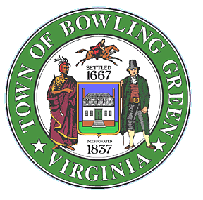
Public Notice
The Bowling Green Town Council will hold a special/meeting/work session beginning at 6 PM on Tuesday, December 5 to discuss the Town’s participation in VDOT’s planned and funded Smart Scale Project.
The Smart Scale project when completed will:
- provide sidewalks along Chase Street and Courthouse Lane
- replace traffic signals at the Chase/Milford and Main Street intersection
- provide improvements that will enhance pedestrian and cyclist safety in the downtown and adjacent areas
- improve safety at the Courthouse Lane and Chase Street intersections with US 301 by adjusting turning movements
- provide a paved, commuter parking lot along Chase Street
The special meeting/work session will include a presentation by VDOT officials concerning the need for the proposed safety improvements, the projects proposed budget, potential timeline and any potential impacts upon the Town followed by questions and discussion with VDOT officials and the Town Council.

No action by the Town Council on the project is anticipated at the work session. Action by the Council on continued support of the application is anticipated at Council’s regularly scheduled meeting to be held on December 7.
The meeting will be held at Town Hall located at 117 Butler Street, Bowling Green, Virginia.
For additional information please contact John Anzivino, Interim Town Manager at 804-633-6212 or townmanager@townofbowlinggreen.com.

